Group 13

Author: 陈怡珺

Traceability Report

HuaRongDao

Table of Contents

System Architecture 2

Software Traceability 2

## System Architecture

The system architecture is shown below:

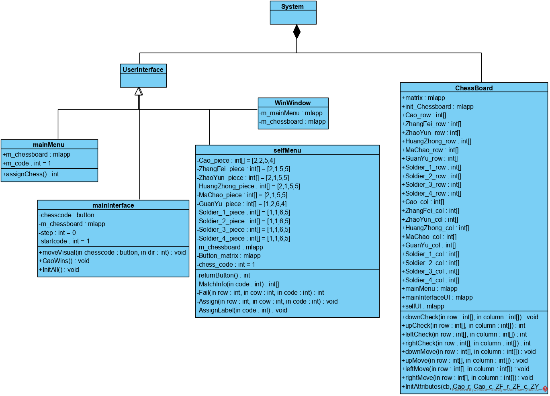

## Software Traceability

|  |  |  |
| --- | --- | --- |
|  | Is implemented by | Is validated by |
| R1.1.1 | S1.1.2  S1.2.3 | T2.3.1.1  T2.3.1.2  T2.3.1.3  T2.3.1.4  T2.3.1.5  T2.3.1.6  T2.3.1.7  T2.3.1.8  T2.3.1.9  T2.3.1.10 |
| R1.1.2 | S1.1.1 | T2.3.1.1  T2.3.1.2  T2.3.1.3  T2.3.1.4  T2.3.1.5  T2.3.1.6  T2.3.1.7  T2.3.1.8  T2.3.1.9  T2.3.1.10 |
| R1.1.3 | S2.1.6  S3.3 | T2.2.8 |
| R1.1.4 | S2.1 | T2.2.4 |
| R1.1.5 | S2.1 | T2.2.5 |
| R1.1.6 | S2.1 | T2.2.4 |
| R1.1.7 | S2.1.5 | T2.2.7 |
| R1.1.8 | S2.1 | T2.2.6 |
| R1.1.9 | S2.1.7 | T2.2.2 |
| R2.1.1 | S2.1.7 | T2.4.1 |
| R2.1.2 | S2.1.7 | T2.4.2 |
| R1.3.1 | S3.1 | T2.1.6 |
| R1.3.2 | S3.1 | T2.1.6 |
| R1.3.3 | S3.1 | T2.1.5 |
| R1.3.4 | S3.2 | T2.1.1 |
| R1.4.1 | S2.1 | T2.2.1 |
| R1.4.2 | S2.1 | T2.2.3 |
| R1.4.3 | S2.1 | T2.2.5 |
| R1.4.4 | S2.1 | T2.2.4 |